

28/7/2015
RE: Kirisun Digital Shipment for [BRG]
Hi Johnny

Would like to apologise for the delay, the shipment will be arriving in Durban on Monday the 1 August.
I am arranging for goods to be pre cleared so we can have stock in your office by the latest Wednesday morning.

Should you have any queries please don’t hesitate to contact me.
Best Regards
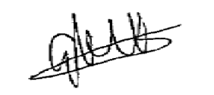


Gregg Mitchell
0836622461

